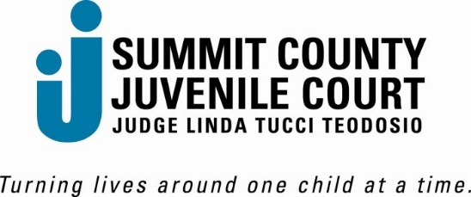

**Human Trafficking 101**

Human Trafficking 101 (HT 101) is a one-time class offered to educate families. The goals of HT 101 are to increase awareness of risk factors, identify safe relationships, and discuss resources.

* Human Trafficking 101 is being held from 5:00pm to 6:15pm
* **Classes are held on the 2nd Tuesday of the month**
  + Youth classes: held on odd months
  + Parent classes: held on even months
* To register, call or e-mail Angela Hart [ahart@cpcourt.summitoh.net](mailto:ahart@cpcourt.summitoh.net) 330.379.3676
* Youth and parents/guardians must attend separate sessions
  + Small children will not be permitted to sit in the class, if held in person.

|  |  |
| --- | --- |
| **Youth Classes** | **Parent/Guardian Classes** |
| January 10, 2023  March 14, 2023  May 9, 2023  July 11, 2023  September 12, 2023  November 14, 2023 | February 14, 2023  April 11, 2023  June 13, 2023  August 8, 2023  October 10, 2023  December 10, 2023 |

**Please call or email to sign up for a class!**